**Data Exploration with SQL**

**-- Select Data that we are going to be starting with**

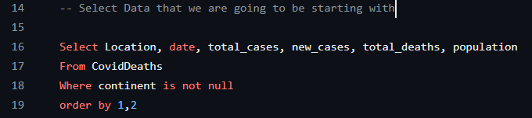

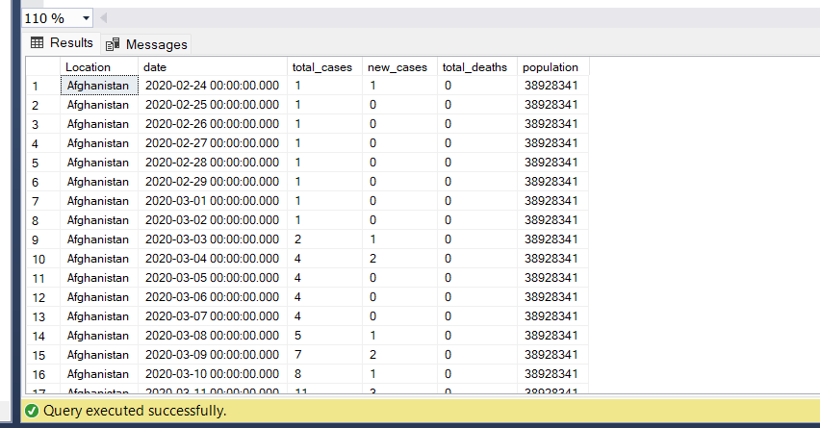

**-- Total Cases vs Total Deaths**

**-- Shows likelihood of dying if you contract covid in your country**

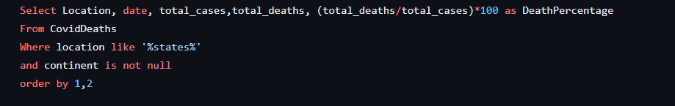

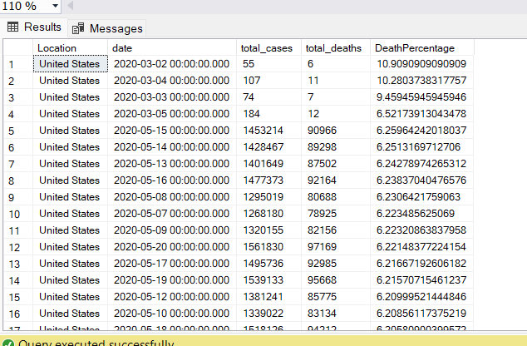

**-- Total Cases vs Population**

**-- Shows what percentage of population infected with Covid**

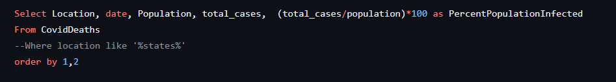

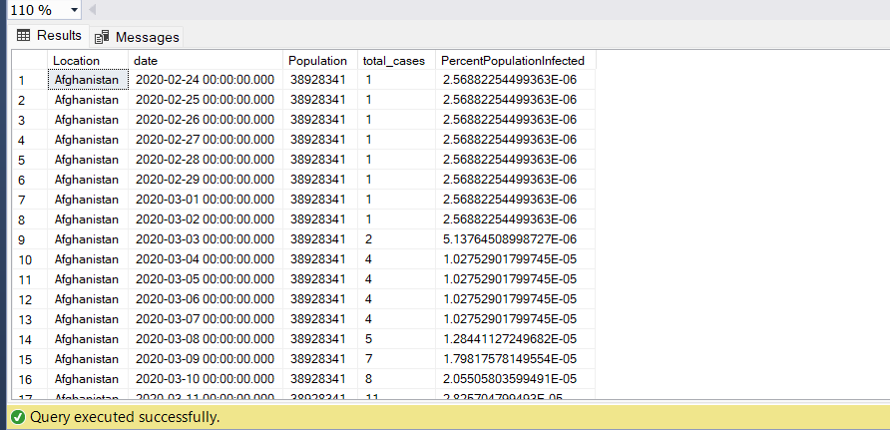

**Countries with Highest Infection Rate compared to Population**

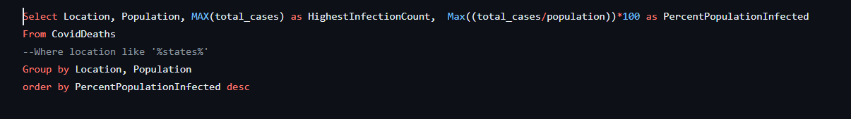

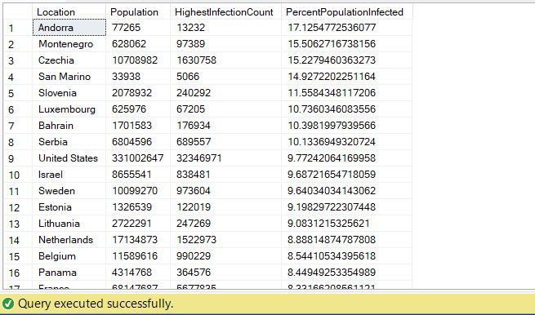

**Countries with Highest Death Count per Population**

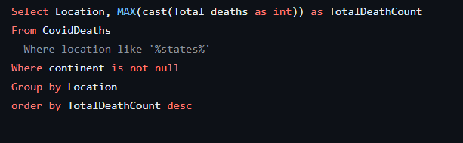

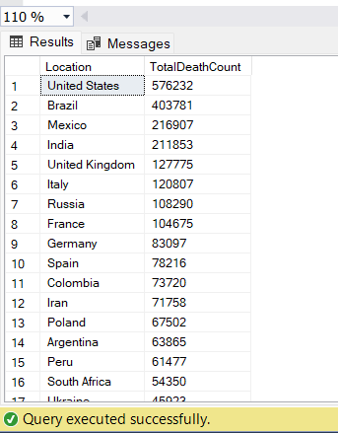

**Showing contintents with the highest death count per population**

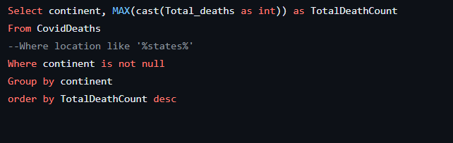

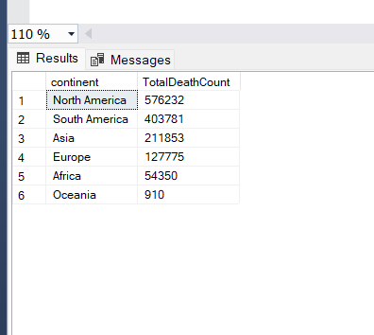

**-- GLOBAL NUMBERS**

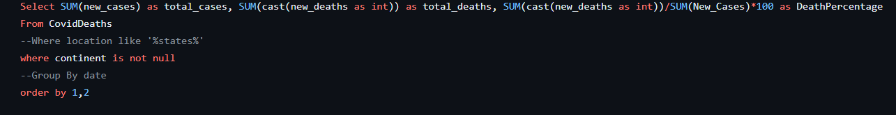

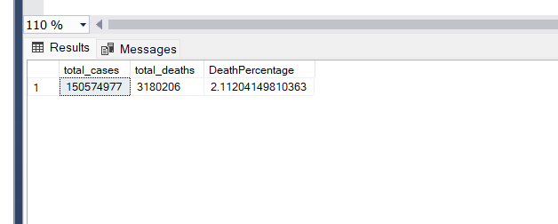

**-- Total Population vs Vaccinations**

**-- Shows Percentage of Population that has recieved at least one Covid Vaccine**

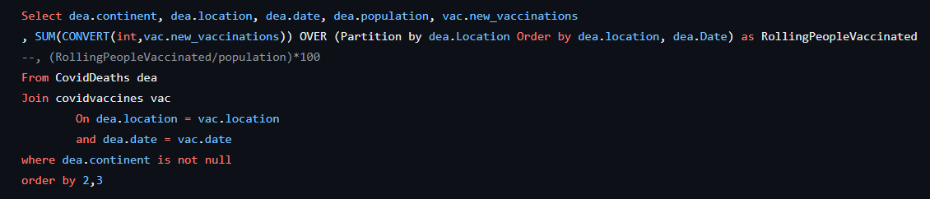

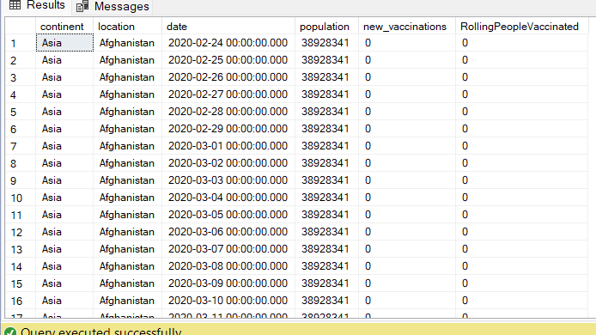

**-- Using CTE to perform Calculation on Partition By in previous query**

